March 2016

**English Version 1.0**

**GUIDEBOOK TO PROCESS EVALUATION**

**Toyota Production System for (Public) Service Organisations**

**MINISTRY OF REGIONAL DEVELOPMENT**

National Coordination Authority

Staroměstské náměstí 6

110 15 Praha 1

**(not)published: 31th March 2016**

# Table of Contents

Table of Contents 3

Acknowledgement 4

Summary 5

Foreword 8

1. Introduction 9

1. 1. Structure of the document 11

2. Origin and basic principles of the Vanguard method 12

2. 1. Two different approaches to management in organisations 12

2. 1. 1. Fordism/Taylorism 12

2. 1. 2. Toyota Production System as a response to a new type of demand 13

2. 1. 3. Traditional management approach vs. Toyota Production System in service organisations 14

2. 2. Management thinking in public administration 18

2. 3. Application of the *Vanguard Method* to analysis of processes designed for service provision 18

3. CHECK! 21

3. 1. Purpose of the organisation (from the client's point of view) 23

3. 2. Value and failure demand: how to understand your work from the client's point of view 27

3. 2. 1. Service from the client's perspective 27

3. 2. 2. Value and failure demand 30

3. 3. Response capability 34

3. 3. 1. What to measure? 34

3. 4. Design of processes: value work and unnecessary work (waste) 38

3. 4. 1. Procedures during the analysis of process design 39

3. 5. System conditions 45

3. 6. Identification of management thinking: assumptions shaping the performance of organisation 48

3. 7. The process of constant learning 55

4. Sources 56

5. List of figures, tables and boxes 58

# Acknowledgement

We would like to take this opportunity and express our gratitude to all of our dear colleagues who have been helping us in our continuous way to knowledge. We would like to especially thank the staff of the Operational Programme Human Resources and Employment and the Operational Programme Technical Assistance, namely then Benedict Wauters (ESF Agency Flanders), Jana Jirků (Ministry of Labour and Social Affairs), Jeremy Cox and Alan Marot (both Vanguard Ltd.).

# Summary

* The Guidebook to Process Evaluation outlines the perspective of the *Toyota Production System for (Public) service organisations* in the EU Structural Funds environment in the Czech Republic. Although the operational programmes process huge quantities of inputs from applicants and beneficiaries, no major evaluations of process administration of ESI funds in the Czech Republic has so far been conducted.
* This publication strongly relies on the methodological recommendations articulated by John Seddon and his colleagues, known as the *Vanguard Method*. The approach is client-driven. Its core is constituted by an analytical phase that should precede the decision-making on the design of functioning of service organisations. *Vanguard Method* makes it possible to reveal those organisation's aspects which have an impact on relations with clients, administrative burden, performance, etc.
* Apart from introducing the analytical steps as such, the publication comprises examples of pilot testing of this method in the Czech Republic, done under the Operational Programme Human Resources and Employment and the Operational Programme Technical Assistance.
* *Vanguard Method* compares the common management approaches that are currently applied in Western countries. The management approaches very often include elements of two entirely different and often contradictory sets of assumptions about how organisations should work. Development of key elements of both the sets of assumptions can be seen in the automotive industry. The management thinking widely used in Western countries, known as “command and control“, was ushered by the Ford automotive company, and now it is one of the main approaches to management of large organisations for example in the area of IT, telecommunications industry and others. It has made its way to public organisations through *New Public Management* thinking. On the other hand, Toyota automotive company has developed a management thinking built on entirely different assumptions of the organisation's functioning. Where the “command and control“ management thinking is applied, it is very difficult to adapt to varied demand. Varied demand is however typical for the service sector. The Seddon's *Vanguard Method*, on the very contrary, enables organisation to better understand variability of its demand, and thus also to better respond to it.
* The cornerstone of the presented method is analytical phase called “check”. It builds on six basic methodological recommendations. Once all the steps are taken, the phase of planning and introducing the changes follows. Then, it is necessary to pass through the analytical phase again. Therefore, the method is cyclical and relies on a never-ending process of learning.
* The first step of the analytical phase consists in defining the purpose of organisation from the client's perspective. A proper definition of purpose provides an answer to the question why the organisation exists and to whom and how it brings the added value.
* The method looks at the organisation “from the outside in“. It is therefore essential to continuously monitor the nature of demand. What do clients want from the organisation? What matters to them and what is the maximum added value they can get from the organisation? What, on the contrary, are the clients dissatisfied with? How often do situations occur when they are dissatisfied and what is the cause thereof? These are questions to which answers can be provided by activities of the second analytical step.
* The third step of the method consists in getting useful information from the already available data, and potential reassessing of what to measure and how to do it purposefully. Measuring generally motivates actions within the organisation, and if usefully designed it enables the members of the organisation to learn to do their work as best as they can. It is therefore necessary to measure what matters to clients and what helps the employees to get better in providing service.
* After assessment of a usefulness of the design of measures in the organisation, a step follows in which the work is analysed. From the client's perspective only such work matters which contributes to fulfilling hers/his requirement. In organisations, also many activities are performed which are not related to what the clients require from them. The performance of these activities simply neither produces the product nor provides the service, and their performance limits the organisation's capacities that could be used for creating activities important for clients. In case the organisation does exclusively what matters to the client, an ideal situation is achieved with no administrative burden, and the service is provided seamlessly.
* Analytical findings of previous steps have to be interpreted in the light of system conditions of the organisation. The system conditions, e.g. distribution of work positions and decision-making powers, division of tasks, setting out of rules and measures or division of resources, directly influence the organisation's features examined in previous steps. If the system conditions, that are crucial determinants of current performance, are successfully identified, the necessary prerequisite of the organisation's capability to increase its performance is met.
* The last step of the method consists in revealing the management assumptions, based on which the organisation's system conditions were created. This step is absolutely necessary. Without it only partial improvements can be achieved within the existing management assumptions. By moving from the client towards the management assumptions the *Vanguard Method* makes it possible to identify the assumptions in management thinking that shall be changed in order for the organisation to bring a higher added value to its clients.
* After analytical phase called “check” planning phase follows. “Plan” phase is composed in activities aiming at thinking about purposeful redesign of system conditions of organisation based on renewed thinking assumptions of management. Goal is to plan how to get rid of identified waste work and how to redesign organisation so that demand would be met in more purposeful way.
* Last phase before whole cycle starts again is “Do” phase. The previously created plan is implemented into everyday work. Newly created becomes normal. There is no finite ideal state of organisation for number of reasons, f. e. because of constantly changing demand. After implementation of plan, organisation that really wants to stay in business needs to start with check phase again and take cyclic approach with the Vanguard Method.
* The method is easily suitable for organisations dealing with regular and predictable demand, but doesn’t depend on it. The ESI Funds organisations in the Czech Republic regularly process project applications, monitoring reports, applications for payment, and their quantities can be roughly predicted. We believe that the method can increase the capability of organisations administering the ESI Funds in the Czech Republic to fulfil their challenging role, and thus to enhance the benefits of the European money for the Czech Republic.

# Foreword

The purpose of the guidebook you are holding in your hands is to introduce the Vanguard Method and elements of “Toyota Production System for (public) service organisations” to audience of members of ESIF organisations in the Czech Republic. The guidebook is a result of almost two years of work with the method, its studying and pilot testing. Pilots were done within the two operational programmes in programming period 2007 – 2013, Operational Programme Technical Assistance and Operational Programme Human Resources and Employment.

Before you dive into exploring the method, we would like to point out some of the important aspects which are useful to have in mind when using the method.

This publication aims to inspire its readers to systems thinking about ESIF organisations so that decisions about system setting of these organisations could be based on useful and valuable information. Publication includes number of tips and tricks and practical examples, which you, readers, can test in your own organisations. As with every other instrument, it is necessary to avoid certain fall pits when using the method.

It is absolutely necessary, that team that is using the Vanguard Method in an organisation has also members from the management of the organisation, that have decision making authority about how a work is done in the organisation. These managers have to be part of the analytical team. They need to be passionate about the knowledge they can gain via using the method. If the weight of understanding the organisation from systems perspective rests on the shoulders of the regular employees and managers will demand only reports with conclusions for their decision making, organisation can never significantly increase its quality. What need to be touched via the change are the assumptions that are present in the management thinking. If these assumptions stays untouched, the core of the problems that organisation faces will remain the same.

Managers need to study the method and then learn it by doing it. Method can’t be understood without testing it on own organisation. For the easier part – studying - we offer this publication, which is a short introduction to the method for Czech audience. To gain more inspiration we recommend to visit the Vanguard Ltd. webpage <http://vanguard-method.net/> or to use resources which are listed in the end of this guide.

As the National Coordination Authority we prepared for those of you who are interested in the method one day workshop, where we present the method and you can also do your first touches through some basic exercises.

We hope that you will find an inspiration and energy in this guide to gain deeper understanding of your own organisation and to develop it into something more purposeful than it is now.

Vladimír Kváča Richard Kokeš

director analyst

National Coordination Authority, Ministry of Regional Development, Czech Republic

# Introduction

The area of the European Structural and Investment Funds (ESIF) is one of the few areas of public policies in the Czech Republic where the evaluation culture has developed at least to a certain degree and where regular evaluation activities have been carried out. The European Union legislation for the 2014-2020 programming period puts a stronger emphasis on evaluations than it was the case in the past. The emphasis is placed particularly on outcome evaluations at the expense of process evaluations. Under the ESIF, these process evaluations focus on assessing the processes of implementation of programmes in the implementation structure organisations.

Even though it is appropriate to accentuate the outcome evaluations of programmes, it is nonetheless obvious that the process evaluations, predominant in the previous period, will be a component part of evaluation activities also in the future. Namely because they show a significant potential to influence the organisation's capability to achieve the coveted results. This is why the Evaluation Unit of the National Coordination Authority has drawn up this Guidebook to Process Evaluations through *Toyota Production System for (Public) Service Organisations* (also known as the *Vanguard Method*, hereinafter referred to as the VGM). This method is in compliance with the Evaluation Plan of the Partnership Agreement applied to process evaluations at the level of the Partnership Agreement. Its power, however, can fully unfold primarily at the level of processes of the managing authorities and intermediate bodies of individual programmes.

The guidebook, you are now holding in your hands, should first and foremost provide you with inspiration and evoke questions. Many of them are essential for the performance of service organisations, and are not often asked, let alone clearly answered with respect to the ESIF.

The VGM offers a way how to get closer to answers to questions such as: Who is the client of the managing authority or the intermediate body? The applicants and beneficiaries? Or the respective minister, or the government? What is the actual purpose of activities of the managing authority? To ensure the absorption of funds? To create conditions for aid beneficiaries so that they could improve as much as possible the quality of life of inhabitants of the Czech Republic? Or to make decisions safe from the audit perspective, and to observe the deadlines?

What do the applicants and beneficiaries actually want? What is it they contact the implementation structure for, when and through what channels? Aren't some of their suggestions and enquiries pointless and bothering? What is it caused by?

To what degree is the implementation structure capable of responding to project applications, monitoring reports or applications for payment?

What part of activities of the managing authority has a true added value for applicants and beneficiaries of the individual programmes? What is done unnecessarily in the implementation of the ESI Funds that blocks the administrative capacity?

Why does the system of administration of funds look as it does? What shall be changed to improve the ESI Funds environment?

This publication offers an instruction how to ask these questions and how to answer them. The questions are key since they facilitate to consistently enhance the ability to provide the service, thus to add value to the service user for their other activities. In simple terms, the answers are essential for improving the quality of service organisation.

We are convinced that the presented framework is fitting for evaluation of the ESIF implementation processes and can also serve as a starting point for their continuous improvement. The process improvement should be one of the main purposes of Technical assistance. In this respect, the “process” evaluation plays the role of outcome evaluation of the Technical assistance priority axis. The technical assistance is used by the implementation structure for its own needs. But even these funds shall be used for activities which generate true added value. This handbook will help you find ways how to assess the effectiveness of spent funds also in Technical assistance. The impact of Technical assistance rests in its contributing to effective implementation of material parts of the programme. It is desirable to change the perception of Technical assistance from being a minor part of the programme which does not have to be talked about much… (Figure 1)

Figure 1 – Conventional concept of Technical assistance – Technical assistance as a parallel activity under the operational programme;

MA + IB activities = Priority axis Technical assistance

OP

Priority axis

1

OP

Priority axis

2

OP

Priority axissa

3

…, to Technical assistance which through its added value increases the effectiveness and efficiency of the other priority axes. Namely those which are really important, those which bring positive changes in the quality of life of the population of the Czech Republic (Figure 2).

Figure 2 – Technical assistance adding value to activities under the other priority axes

MA and IB activities =   
Prioriy axis Technical assistance

OP

Priority axis

1

OP

Priority axis

2

OP

Priority axis

3

*Value added by Technical assistance*

Shift in perspective

MA + IB activities = Priority axis Technical assistance

OP

Priority axis

1

OP

Priority axis

2

OP

Priority axis

3

## Structure of the document

The publication, you are now holding in your hands, aims at inspiring reflections on the actual work from a new perspective. From the perspective which believes in analytical thoroughness, which brings positive changes for organisation and its employees. The perspective of *Toyota Production System for Service Organisations* has extremely rich and fascinating theoretical base in which its methodological recommendations are grounded. Nonetheless, this document has been designed as a practical introduction, which is why the theoretical roots are covered to a limited degree only.

The principal part of the document is chapter three which presents the *Toyota Production System for Service Organisations* applied by the British Vanguard Ltd company. Its staff has been developing methodological recommendations on how to analyse an organisation in six basic steps. The chapter three describes the individual steps as they are stated in the Vanguard method handbooks. The methodological description is also supplemented by other observations and experience with application of this method in the environment of the EU Structural Funds in the Czech Republic.

Apart from theoretical background of each analytical step, the manual comprises also recommendations for the procedure to be taken in the conduct of analyses at the actual workplace, and always adds some lessons learned during the already conducted attempts to apply this method.

Even though this manual is definitely not a comprehensive handbook of the presented method, its authors would appreciate if it stirs up desire for getting a more in-depth knowledge of the method, whether through further studies, or practical application.

# Origin and basic principles of the Vanguard method

The VGM was developed by John Seddon and his team from the United Kingdom. Basically, they adapted the approach taken by Toyota automotive company to the area of provision of services, including public services. They offered the managers of service organisations a different perspective representing potential of “levers for change“ of performance, i.e. changes substantially increasing the performance and quality.

The following comparison of two main management lines from the world of automotive industry may seem strange in the introduction to the *Vanguard Method* for public administration practitioners, but the original American approach and development of management in industry significantly influenced the shape of management in services in Western countries in general. Toyota, the Japanese car manufacturer has offered an alternative and has become the largest and most successful car manufacturer in the world despite the challenging conditions in Japan after the World War II. John Seddon has exploited the strengths of “*Toyota Production System*“ and with the use of information from its application in practice has been consistently developing the so called “*Toyota Production System for Service Organisations*“ (hereinafter referred to as the TPS).

A brief comparison of two schools of thought

serves as an introduction explaining the difference between the “*Toyota Production System*“ approach and the traditional Western industrial management approach. Both the approaches are actually present in services. They are applied through such frameworks as the *New Public Management* on the one hand or the *Vanguard Method* on the other hand.

## Two different approaches to management in organisations

### Fordism/Taylorism

Ranking among the famous pioneers of management methods is Henry Ford and Frederic Taylor, his senior management strategist. Together they have brought the Ford Motor Company into an unprecedented expansion. The aim was to build a factory where individual activities are strictly broken down and each person is responsible for performance of a single simple activity only. The decision-making was fully separated from work, the managers devised a production line consisting of a series of simple tasks. In the end, it was not even necessary for the workers to speak English. Their simple and repetitive tasks were standardised and the compliance with the standards was closely supervised.

It worked very well at that time. The wages in Henry Ford's factories kept rising and the production costs kept decreasing. The working conditions of a person performing routinely a trivial task, however, were unbearable and the worker stood the work no more than 3 months on average. Conducive to the success of this method was little variety of production. As a matter of fact, a single identical model was manufactured which filled up the warehouses. The sales department subsequently made sure the warehouses full of cars were emptied by selling the products to customers. In case the sales were slow, marketing, discounts, etc. played an important role (for more see Seddon, 2005:12-15).

Work standardization, supervision of the observance of standards and decision-making separated from work based on fulfilling the pre-defined indicators tied to financial budgets were then scaled up to management processes of industrial companies of Western Europe of the 20th century, namely not only into industries, but also to service-oriented companies (an example being the ISO 9001 standard[1], SMART goals, defined standard periods for various activities, fragmentation of the system of organisations into functional units, etc.).

### Toyota Production System as a response to a new type of demand

Taiichi Ohno, the Toyota managing director after the World War II, was thinking about a way in which Toyota may develop and confronted his observations from the Ford's factories in the United States with the ideas of W. Edwards Deming. W. Edwards Deming, even though he was an American, at first failed to push through his thoughts into the practice of American companies. He offered an alternative that was used by Taiichi Ohno (for more see Seddon, 2005:19-24).

Due to economic reasons in the post-war period, Toyota was simply unable to apply the American production method requiring high initial investments in Japan. The American car manufacturers made large quantities of cars “to stock“ and then customized them and sold them. Toyota introduced production responding directly to the demand. The production of a specific car was launched only after an order had been received. This eliminates the necessity of massive stocks. The key measure in Toyota is the speed of production of the whole car, i.e. the order is received from the car buyer and then the car is produced and supplied as soon as possible. Simply, the aim was to cut short to a maximum the time between the receipt of the order and collection of money for the sold car.

With the growing number of car owners after the World War II, also increasing was the number of various requirements for car properties. Contrary to the American and German car manufacturers who broke down the production into individual functionally specialised steps and gradually made the car manufacturing more efficient, in Toyota they tried to find a way how to rearrange the production line as fast as possible and concurrently reduce the time between the receipt of the order, car production in line with the customer's requirements and its delivery.

Over the years, Toyota developed a number of methods how to achieve this goal. The basic tool for improving the quality of production was delegating a great portion of decision-making powers to workers who actually manufacture the cars. The workers in the car manufacturing process are not bound by rigid standards, contrarily their ability to learn how to do their work better is encouraged. The managers are apart from other things tasked to collect information on potential improvements from the workers “on production line” and based on this information to change the system of work for the better. Toyota works on the assumption that those who do the respective work understand it the best. This approach had a few advantages as against the American way. E.g. satisfaction of employees or also a high innovation potential, thanks to which already in 1950s Toyota was able to rearrange the car production line in ten minutes, whereas it took the American car manufacturers ten days (Seddon, Caulkin, 2007:13). At the end of 1980s Toyota needed fewer hours for production of the whole Lexus (Toyota luxury brand) ready to be delivered to the client than the German car manufacturers did for reworking the already produced standard luxury car to meet the specific needs of the customer (Seddon, 2005:15).

The headstart of Toyota brought about by a different way of thinking behind the management is evident until now. Toyota cars have consistently belonged to the most reliable and best-selling cars. Approximately ten million Toyota cars are sold annually, which is similar to the number of cars sold by the German car manufacturer Volkswagen. Toyota, however, achieves this result with nearly a half of the employees (594 000 Volkswagen, 345 000 Toyota) (Statista, 2014, Toyota, 2014).

### Traditional management approach vs. Toyota Production System in service organisations

Two different approaches to management in organisations in industrial environment have also made their way to service organisations (especially to the so called corporations). The TPS offers an approach which more strongly reflects the nature of services in 2015. Such as their very limited possibility to make “to stock“ and their usually present high variety of clients' demands. These are aspects that the Ford's management method has a difficulty to cope with and that result in low quality and efficiency of services.

**The traditional management approach** originates from industrial setting and is known as “command and control“. Managers adhering to the traditional way of work tend to break down the work in the organisation into smaller tasks down to the so called “last screw“ and make the staff specialize in performing simpler tasks many times. The supervision over the tasks of employees is intensified. By increasing the performance of individual employees, they increase the performance of the organisation as a whole. This, however, is accompanied also by many difficulties. Transaction costs on information transfer and on the actual flow of intermediate outputs through the system are incurred among specialised workers who concentrate on their intermediate outputs. When the products flow through the organisation, problems may arise with respect to the compatibility of individual intermediate outputs, and the likelihood of defects increases. At the same time, on the other hand, the likelihood of early detection of these defects and potential identification of causes decreases. Also, rivalry may occur between the individual sections, problems may be shifted to other sections, etc.

Traditional management views the organisation as a hierarchical structure where decision-making roles and work performance are strictly separated. Thus, certain employees do the thinking and make decisions how the work should be done, while the others follow these procedures in manufacturing the products or providing the services. Measures serve to monitor whether the managerial decisions are followed by employees. Thus measurement often takes the form of standards with the target values, etc. The managerial staff shall ensure the accomplishment of the set out objectives and manage their subordinates to this end. Accomplishment of objectives is thus commonly decomposed to the level of an individual, with each employee having his own performance standard based on the assumption that by adding up the performance of individual employees the set out objective will be accomplished.

Motivation of employees is external and their performance is assessed based on the arbitrarily in a “top-down“ manner set out measures the fulfilment of which is checked. The expected performance, however, mostly fails to reflect the abilities of each individual, for someone it is too low, while for someone else it is too high. In case of low performance, bonuses or sanctions or other typical external motivation tools are linked to the target values. Organisation of this type tends to have an issue with opening up to the external environment. Responsivity thereto is limited, the organisation runs rather in line with a predefined plan and the issues are dealt with in a reactive manner. This is caused by having the objectives set hierarchically, i.e. by top managers who are remote from everyday contact of the organisation with the external environment, or are far from the so called “front office“.

“*Our organisational roles are based on command-and-control thinking. We thing of our organisations as top-down hierarchies, we separate decision making from work, we expect managers to make decisions with measures like budgets , standards, activity and so on. We teach managers that their job is to manage people and manage budgets. These are the principles and practices that constitutes command-and-control management.” (Seddon, 2005:8)*

In organisations providing services related to satisfying the complex human needs, it is a big challenge for the traditional management to keep pace with the external environment. Such management tends to limit the ability of employees directly providing the service to satisfy the extremely varied demands and needs of individual clients. Moreover, the organisation has only a very limited ability to detect any changes in the environment and to respond to its variability. Decisions are made by managers remote from any contact of the organisation with the external environment. Information gathered by these managers does not tell them much about demands imposed by the external environment on the organisation. Instead of that, they have information about how workers respond to requirements placed on them by the managers. These issues are responded to by the *Vanguard Method*.

***Toyota Production System* and the *Vanguard method*** inspired by it approach the organisation management in a completely different manner. An organisation is no more primarily perceived as a hierarchy, but as a system which exists in order to respond to the demand. Demand is an initiative of the external environment, requiring a response of the organisation and an output with certain properties. In case of services, the output can be the satisfaction of a particular need. The perspective in which the organisation is seen thus changes from “top-down“ to “outside-in“.

*Design of processes* within the organisation is unlike the traditional functionalist concept of management determined by

* Nature of demand which shall be satisfied by the organisation,
* Identification of valuable work that shall be performed in order to satisfy the demand,
* Monitoring those aspects of performance that matters the most to the client.

*Decision-making* is integrated with work which means that a substantial part of decision-making powers is borne by those who provide the service concerned (“front office“).

*Measures* are oriented at obtaining information usable for learning about one's own performance. It monitors what the customers demand from the organisation and how the organisation responds to it. It measures the ability to fulfil the purpose of the organisation, i.e. to what extent the organisation adds value to customers for their other activities. It also measures how much work does not contribute to fulfilling the purpose. Such work can be considered entirely unnecessary, thus the system causes, due to which such work needs to be done, shall be reduced. It relies on the internal motivation of workers who avail of the information helping them to improve their work. It is therefore necessary that the workers are endowed with sufficient autonomy enabling them to use the best of them in their work.

*The role of managers* is to analyse and design the organisation's system which as a whole is responsible for the quality of provided service. Supervision of rank and file employees and a detailed description of work tasks are sidelined. On the very contrary, the insight of employees who provide services or directly produce the products is key for the managers. Namely, because the rank and file workers are best suited to understand the pros and cons of processes of which they are a component part. The role of managers is simply to enable the “front office“ employees to provide the service of the highest possible quality. To help them improve their own performance and to create favourable conditions for their self-fulfilment. In brief, the approach points at the benefits reaped by the organisation in case the “front office“ employees avail of sufficient autonomy. The organisation can be more open to the external environment, it can more flexibly respond to it and absorb much greater variability (diversity) of requirements associated with processing of the demand.

**Table 1: *Different principles of the traditional “command and control“ management thinking and the “systems thinking“***

|  |  |  |
| --- | --- | --- |
| Principles of  “Command and Control“ |  | Principles of  “Systems thinking“ |
| Top-down, hierarchy | **Perspective** | Outside-in, system |
| Functional specialization | **Design** | Demand, value, flow |
| Separated from work | **Decision-making** | Integrated with work |
| Outputs, standard objectives related to budget | **Measures** | Capability and variation, related to purpose |
| Contractual | **Attitude to customers** | What matters? |
| Contractual | **Attitude to suppliers** | Cooperation, partnering |
| Manage budgets, manage people | **Management ethic** | Act on the system |
| Extrinsic | **Motivation** | Intrinsic |

SOURCE: Presentation by Alan Marot (Vanguard Ltd., Prague: January 2015)

## Management thinking in public administration

Traditional management of public administration was historically based on the “command and control“ management thinking. Conventional Weberian public administration system puts an emphasis on hierarchical arrangement and depersonalization of individual work positions. The officials are responsible for observing the rules and clearly defined procedures, the fulfilment of which is controlled. The principles of “command and control“ management were reinforced as a result of enforcing the *New Public Management* principles in public administration practice all over the world. The managers shall measure and based on measures manage and decide, without getting into contact with the direct provision of the service. It is supported by the collected data. Decision-making and the actual work performance are thus clearly separated. The emphasis on the target values of measured indicators and control of workers in terms of achieving the target values are typical examples of external motivation. Negative effects described in the previous chapter moreover contribute to decreasing the internal motivation.

## Application of the *Vanguard Method* to analysis of processes designed for service provision

The VGM perceives the organisation as a system. This holistic perspective assumes that the quality of organisation is higher than the sum total of qualities of its individual parts. Or, that the performance of the system does not depend only on the elements (quality of people), but also significantly on their relations and on the principles it is governed by. It is therefore necessary to concentrate the efforts on system elements, directly influencing the people's behaviour. To perceive the organisation from the input up to the output and to avoid any distortions by focusing on the selected parts only.

Where the organisation applies the VGM principles on a continuous basis, its ability to adapt and organisational learning increases. It is achieved having confidence in “front office“ employees, which lead to their higher autonomy. “Front office“ provides valuable information to managers about what features of the provided service are relevant to clients and on what the organisation shall focus if it wishes to improve its quality.

The managers are tasked to design the system, which enables to absorb the variety of demand. They also monitor where in the organisation the added value is created for customers and where activities are performed which have nothing to do with the customers. This information of analytical value is used to identify system conditions influencing the nature of obtained data, i.e. the features of the provided services. The method, however, does not end here. Each system is constructed based on assumptions concerning the functionality of its specific design. If, however, these assumptions are wrong, a redesign of the system cannot bring the desired effects. Thus, it is always necessary to take a step further. The successful managers shall identify and, if need be, rethink the assumptions on which the organisation's system and provided services are based. Only a change in thinking and assumptions can really result in a substantial change of the system itself, and thus also in the performance (Figure 3).

***Figure 3: Basic chart of the Vanguard method***

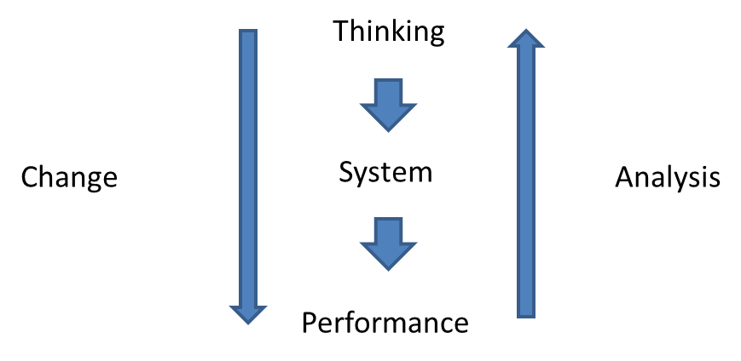

SOURCE: Presentation by Alan Marot (Vanguard Ltd., Prague: January 2015)

After the system is redesigned, data on actual performance is collected again and a continuous, never-ending process of learning about its own performance and about what influences this performance begins (Figure 4). The VGM offers a procedure how to approach the analysis of the organisation's performance. Only after a thorough analysis a change of the system is planned, which is based on the redefined assumptions. The execution of the change is again assessed as to whether the change has fulfilled the expectations, or whether new issues have emerged. Each cycle is then conducive to improvement of the provided services. Nonetheless, you cannot learn the VGM from books. You learn the *Vanguard Method* by applying it. Each executed cycle results in improving and specifying the data collection and increases the ability to understand the system conditions and assumptions, based on which the organisation operates.

***Figure 4: Vanguard method cycle***

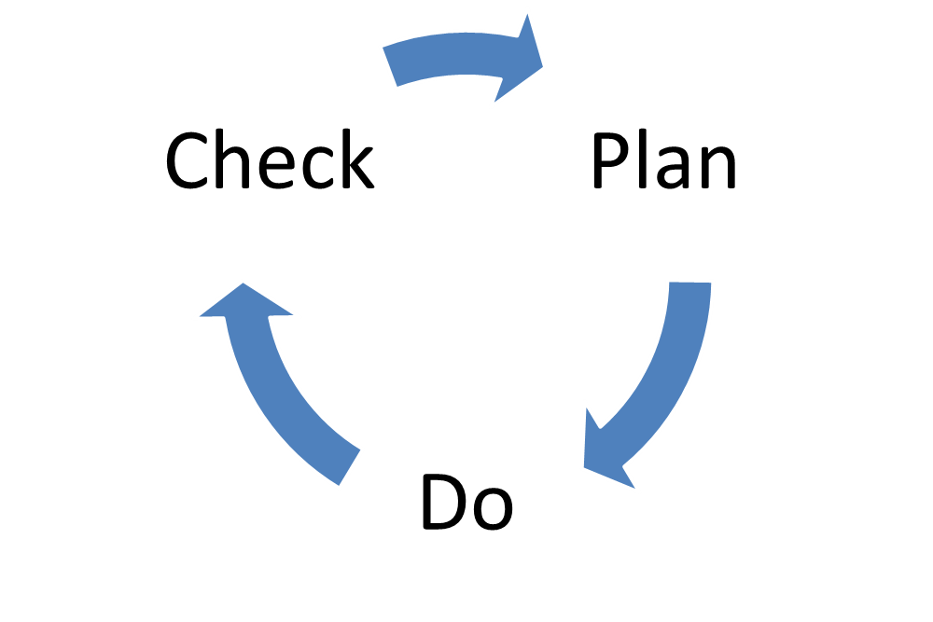

SOURCE: Presentation by Alan Marot (Vanguard Ltd., Prague: January 2015)

The Vanguard Method is based on thorough understanding of client demand which provides information about what is valuable for clients on organisational performance. In the case of operational programs, direct clients are project applicants and project promoters; also target groups need to be considered as the clients, but with bearing in mind they are not in direct sphere of influence. And in the most general way, citizens of Czech Republic are the clients. Managing authorities need to understand project promoters as much as they can, so they can address their needs and at the same time support behaviour of project promoters, which will lead to benefits for the clients which are not in direct sphere of influence, such as target groups and citizens of Czech Republic. To put this assumption in a simple way, better understanding of project promoters will enable managing authorities to influence behaviour of project promoters in a more purposeful way for target groups.

# CHECK!

The VGM starts with analysis of the design of the current system of the organisation. It can be very deep aiming at more robust understanding of organisation as a system, or quick targeting easy gains. The main idea is to get useful data on which informed decision can be based. Decision making in Czech public administration too often relies only on experiences of the managers. These are of course also important, but they will contribute more to the quality of decision-making if accompanied by supporting analytical materials. It happens too often when design of organisation's processes is changed that an in-depth analytical phase is missing. Decisions then have high chance that they won’t bring the change that is expected. It is because assumptions behind these decisions aren’t usually challenged.

The method starts with determining the purpose of the organisation from the perspective of its clients. This part is essential since the following steps of analysis monitor those aspects of the organisation related to the fulfilment of the purpose. The VGM defines the capacity of the organisation to fulfil the purpose of its existence as a sum total of valuable work and waste (Figure 5). Waste represents all activities that do not lead to fulfilling the purpose, and thus limit the capacity to fulfil the purpose. Waste is generated in two ways. Either the organisation has to respond to the demand of its clients which was caused by the organisation's inability to meet their demands (“How much longer will I have to wait“), or it is a result of internal design of the system which generates the so called waste (unnecessary work) (for example completing forms whose purpose nobody knows any more). Commonly, the organisations spend more than 50 % of their capacity to deal with the waste and less volume is then left for value work.

This view differs from a more common perception of the organisation's capacity. Managers usually see the capacity of their organisation as a product of the number of tasks and average time necessary for their accomplishment (or, as a sum total of products of individual tasks and the time necessary to accomplish them). Hence, they seek to increase the capacities through having more employees rather than through a change of the system design which generates failure demand and waste (unnecessary work).

***Figure 5: Organisation capacity viewed by the Vanguard Method***

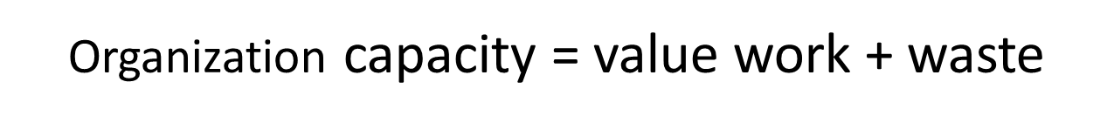

The VGM therefore always begins with the broadest possible analytical phase, the aim of which is to find out how well the organisation works from the customers' point of view and how much waste it has to absorb. Subsequently, system conditions are identified that cause the waste. The identified system conditions are always built on certain ideas why they should work. A critical assessment of these ideas and their potential rethinking is the key precondition of success of the system redesign (Figure 6).

***Figure 6: Chart of the Check! phase of the Vanguard method***

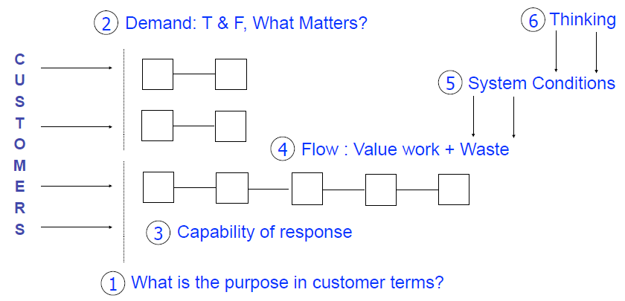

SOURCE: Presentation by Alan Marot (Vanguard Ltd., Prague: January 2015)

**Box 1: Who is the client under the ESIF?**

The term client can be understood in different ways; here we use it generally for a person, who for its own activities uses added value provided by someone else.

Operational programmes have a fairly specific position in the public sector. Their role is to guarantee the achievement of strategically defined social outcomes through funds available from the ESIF. They themselves, however, do not provide any services, which would directly influence the life of citizens of the Czech Republic. They achieve the outcomes through supporting activities which are done by project promoters. Therefore, there are two types of clients of the operational programmes. First of all, the citizens of the Czech Republic, whose quality of life should improve thanks to the ESIF resources.

Secondly and the most importantly, the clients are the project applicants and beneficiaries, without whom the programme objectives could not be accomplished.

The main task of organisations administering the operational programmes is therefore to properly motivate and guide project promoters to accomplishing the objectives linked to the everyday life of citizens. Crucial for this task is an ability to understand those aspects of own performance that help or hinder project promoters to achieve their goals the most.

## Purpose of the organisation (from the client's point of view)

The application of the VGM is directly related to service organisations. The purpose of the service organisation is basically to satisfy certain needs of its clients. A functioning organisation is such an organisation that is able to ensure the satisfaction of needs of its own clients. The long-term perspective of the organisation's existence depends on the ability to satisfy the needs of the clients. If the organisation fails over a long period and is unable to meet the expectations, there is no reason for its existence in this form. It is because the respective clients' needs are satisfied by competing organisations. In case of absence of competing organisations, which often happens in public services, the service fails to address the social issue because of which it was set up.

The organisations of public administration do not always have a clearly and specifically defined client. They, however, always pursue fulfil the specific public interest. Moreover, they often have more clients, for example in the form of a nominated representative of citizens (minister), particular citizens (unemployed persons), service providers (for example beneficiaries in the ESIF environment), other organisations of public administration (National Coordination Authority of the ESIF), etc. Thus, every organisation in services, whether public or private, has in a vast majority of cases a number of different customers, provides more types of services and its purpose is viewed differently by each of them. It is therefore appropriate to design the purpose for each type of the customer, or for each type of the provided service.

If a public organisation doesn’t have citizens as direct clients, that doesn’t mean their ultimate purpose isn’t in adding value to citizen’s wellbeing. Purpose of such organisation is then to enable different part of public administration to add value to citizen’s wellbeing. Without considering if public organisation helps at least other organisations to add value to citizens, such organisation can easily be waste as such. Activities of organisation without having purpose in mind often leads to complication for clients, useless administrative burden, etc.

***Figure 7: “Outside-in” perspective of the organisation***

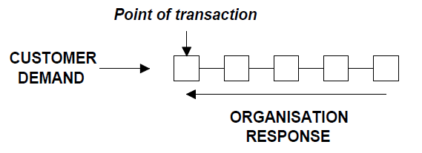

Source: Vanguard_2001a:38

The nature of functioning of a service organisation can be illustrated on three building blocks (Figure 7). On the one hand, there are persons with needs that they are unable to satisfy themselves. They contact the organisation, which they believe is able to satisfy the need, through the point of transaction designated for that purpose (telephone, counter, e-mail, etc.). After placing the demand, the organisation responds, ideally by satisfying the client's needs. If at the point of transaction the organisation does merely what matters to the customer, a high quality of service and optimum cost-effectiveness are achieved. Thus, the purpose of organisation shall focus on an ideal service provided at the point of transaction, i.e. on a service doing what matters to the clients.

Defining the purpose of the organisation from the customer's point of view is a never-ending process. Just like the external environment is changing, also the customers' needs are gradually changing. An ongoing debate on the purpose of the organisation enables an ongoing reflection of the relevance of the organisation’s design. An integral part of this debate is a continuous collection of data about what matters to the clients in the service provision and what the service adding the maximum value to the clients looks like. This way the organisation is also able to detect changes in the environment and to adapt to them. Employees of the whole organisation should get involved in defining the purpose so that it also reflects what matters to them, why they go to work, and so that it motivates them in their everyday activities. This promotes teamwork, sharing the meaning and feeling of mutuality. Then, the purpose is a starting point for every decision-making in the organisation. If the purpose is not discussed, people create their own ideas about the meaning of their presence in the process, which then determine their behaviour. Determination of the purpose also makes it possible to identify and discriminate the performed work which has a value and contributes to accomplishing the purpose from that which is not like that, is therefore as a matter of fact unnecessary.

**Box 2: What might be useful approach for identifying the purpose of the organisation/ the purpose of the process?**

Work on determining the purpose of the organisation and subsequently the purpose of individual processes shall be initiated by managers. As many employees and clients as possible shall get involved in defining the purpose. The employees will be given room to communicate their opinion on why they go to work every day and what makes their work meaningful to them. Continuous mapping of the clients' ideas about the purpose of the organisation helps the organisation keep up with the environment. The VGM authors recommend the following procedure (Vanguard, 2001c:59, supplemented with the author's observations):

1. **To approach the individual employees and ask them what in their opinion is the purpose of the organisation in which they work**

How would the employees describe by what their organisation adds value to the clients? By what the particular services add value?

1. **To assess the collected data**

To what extent are the employees' opinions identical, diverse? What do they stress the most? Do the employees define the purpose from the point of view of the customer, or from the point of view of the organisation?

How do the purposes, attributed by the employees to the processes of which they are a component part, relate to the general purpose of the organisation?

1. **To obtain data on the purpose of individual processes from the clients’ point of view**

In order to understand what matters to the clients, it is necessary to start to discuss the services with the clients and attempt to avoid one's own bias. The data collection shall focus mostly on perceiving the services from the user's point of view.

Examples of questions for clients concerning the service quality:

* *What problems would you face if we were unable to provide you with the service you currently use?*
* *Which of our activities do you consider the most useful/useful for your activities?*
* *Do we provide you together with the service also with elements which you do not want and which complicate other activities of yours?*
* *Can you say what would help you in using our service that we currently do not provide you with?*
* *Can you identify the cases when we caused problems to you?*
* *How challenging is it to cooperate with us, and why?*
* *Rate our service on the scale from 1 to 10 (10 is the best). If you do not give a ten, why?*

1. **To define the purpose of the organisation and processes from the clients’ perspective**

Information gathered from employees and clients can serve as a top quality foundation for defining the purpose of the organisation and of individual processes. Nonetheless, it is essential to view the purposes as fairly dynamic. They will certainly change, either based on better understanding of the customers' demands, or ideas of employees, or based on changes of the external environment.

**Box 3: Our Comments from seeking the purpose of organisations active in the ESIF environment**

The declared purpose of organisations such as the managing authority or the intermediate body is often something like “to approve eligible projects which are in the public interest“, sometimes this purpose is elaborated into more broadly articulated missions or visions:

*“We feel that the purpose of our work is not only the smooth administration of the EU funds. We also feel to be co-responsible for the implementation of quality projects that bring benefits to the citizens and visitors of the Czech Republic. Projects thanks to which life is better in the Czech Republic.“* (IROP, 2014)

*“We successfully develop and manage programmes that use the ESF resources. We support meaningful projects that contribute to better employability of persons in the labour market, adaptability and competitiveness of enterprises, and higher quality of public services. We focus on long-term effects of programmes and projects, we manage the programmes by results. We consistently develop a qualified, stable and motivated working team. We have been given mandate to manage the ESF 2014+. We are open, transparent, communicative.“* (MoLSA, 2011)

*“Based on permanent* *partnership thinking the PMO challenges – with EU and national resources – organisations to initiate actions that sustainably improve the functioning of the labour market. The PMO acquires and shares the knowledge to contribute to solutions for today and tomorrow*.”([vision for the ESF Agency Flanders], Wauters, 2012:81).

In practice, such a positive purpose of the organisation is lowered to de facto purpose such as “to make decisions justifiable (vis-à-vis the audit), to follow deadlines and maximize absorption“. Despite the efforts to create common meaningful organisational visions, we do not consider the introduction of the declared vision in the practical application such a success that it would actually influence the behaviour of employees. It is often caused by the fact that no further steps follow on the vision. For example criteria are measured and reflected that are unrelated to the declared vision, such as the importance of the quantity of absorbed funds. None of the declared visions of Czech organisations states as a criterion the absorption of all available funds, while in reality it is the most frequently monitored measure. Thus, the visions are in contradiction with what is really considered important. Such visions are not present in everyday decision-making and have not the desired positive effects on the organisation's operation.

## Value and failure demand: how to understand your work from the client's point of view

The second step of the Vanguard method is a partly routine and partly occasional analysis of relations between the clients of a particular service and the service organisation. The VGM offers two analytical perspectives of expectations and demands of clients. One part of analytical activities should zero in rather on qualitative and continuous monitoring of aspects that matter to clients in the receipt of service, and in general on better understanding of the added value expected by the clients from the service. The other part is a quantitative analysis of demand, i.e. all suggestions made by the clients, when the clients expect a particular response of the organisation.

### Service from the client's perspective

The VGM views the organisation as a system that is built in response to the demand, the satisfaction of which is achieved by producing certain outputs. The more the output satisfies the client's expectations, or adds value for him, the higher is the output’s quality. Quite often, and especially in organisations managed by the “command and control“ approach, the nature of the service is designed from the top. The managers act based on their experience, design the rules for provision of the service, and subsequently check how employees comply with the rules. They assume that they are capable of designing a service conforming to the clients’ demands. The from the top designated and by rules hampered design of the service, however, faces difficulties in case of a more complicated nature of the clients’ needs. The service users often have diverse needs in terms of time, quality and quantity. Top-down design of the service assumes rather homogenous needs of clients and thus cannot reflect the variable demand. The client then fails to receive the service matching his specific situation. Detailed knowledge of demands and needs of the customers, to whom the service is provided, is the key prerequisite of a customer-driven organisation. It is important to focus the data collection on two aspects. The first one is features of the service that matter to the client in the service provision. The other aspect is the understanding of the added value which the service brings the clients. Or, finding out what would the service which would bring the maximum added value to the client's particular situation look like. The ability to understand the results and impacts of the provided service helps better design the service. The organisation does not concentrate on what is the service like, but on what the customer gets out of it (Vanguard, 2001a:65-66).

A traditional question asked by the managers is: “How well do we do?“. The answer is based on the understanding within the organisation. When the question posed to the customers is reworded into “How does the service help you?“, “What do you do with it?“, “What matters to you with respect to our service?“, completely different information is usually obtained (Vanguard, 2001a:68). Such data helps the organisation understand how well it does with respect to its purpose.

**Box 4: One of the useful procedures how to generate data relevant for understanding client needs and demand**

1. **Data collection**

The quality of service is defined by the client and different clients can have different qualitative criteria. It is crucial that the data is collected through discussions with customers. Such a discussion should be a component part of the standard operation of the organisation and should therefore be held by employees of the so called “front office“, who are closest to the customers. Together with receiving the demand it is therefore useful to collect information about what matters to the clients in service delivery and what is the added value for them, because of which they demand the service.

It is also appropriate to hold a meeting with clients (e.g. applicants or beneficiaries) directly dedicated to this purpose. It provides room for an open discussion. The experience shows that it is a mutually beneficial process, during which apart from generating important information on service quality also the understanding of both the parties of the prevailing conditions increases. In case of employees of the operational programmes and beneficiaries the quality of their relation is of major importance. The beneficiaries represent the only possibility for the operational programmes to improve the quality of life of target groups. The partnership makes it possible to implement projects of better quality.

A questionnaire survey is not always suitable for this data collection since it is too rigid and it is arranged around a structure, and thus limits the collection of information by pre-defined questions. It is pivotal to give room to the client and his perspective.

The data collection can include questions such as: “What makes our service useful to you?”, “What does our service enable you to do and how can we modify it in order for it to become even more useful?”, “What matters most to you as to our actions when you are using our service?”, etc.

1. **Data evaluation**

The collected data should be used by the managers in order to identify those aspects of service quality that are most frequently mentioned by the clients. Subsequently, measures should be created that will be able to capture the quality of service provision from the client's perspective. Thus, when clients state that it matters to them how fast the service is provided, it is appropriate to monitor the time of service provision from the moment the client places the demand until the moment the client is satisfied with the service. Simply, the obtained data serves as a basis for developing the satisfaction rate indicators.

It is essential that the process of data collection and evaluation is repeated in cycles in order to reflect the changes in external environment, and thus also the change in the clients' perception of the service quality. Monitoring of these indicators and factors influencing them is one of the ways how to consistently improve the quality of provided service.

**Warning:** It is inappropriate to set the target values of indicators. These values are also determined from within the organisation, do not take into account the abilities of individual employees and result in considerable reduction of data validity or data ability to give reliable information on the situation. Standards and target values destroy the indicators' ability to serve as a tool for learning – enhancing the performance.

**Box4: Continuation**

Tools for understanding the character of client needs and demand are also useful for relationship building. Better relationship (meaning for example higher trust) enables managing authorities to influence behaviour of their beneficiaries in a more important way.

Beneficiaries are those who directly add value to target groups, which is what is managing authority interested in. If managing authority could support this demand driven thinking of beneficiaries, it would be very useful for ESIF as such, beneficiaries would provide better quality services with higher added value for target groups.

**Box 5: What we have learned from meeting with the OP HRE beneficiaries (“focus group“)**

In order to ascertain the information from beneficiaries on their perspective and experience with functioning of the Operational Programme Human Resources and Employment, the Managing Authority held a focus group with approximately ten beneficiaries. Apart from a very positive effect on relations between the employees of the Managing Authority and the beneficiaries, a lot of substantial information was gathered about what matters to the beneficiaries and how they understand the provided service.

One of the important identified features of the provided service is its correct timing. The beneficiaries stated that the shape of the preparatory training courses suits them, while the dates of these training courses do not suit them at all. The trainings of beneficiaries on elaborating the monitoring reports were held half a year before the beneficiaries actually worked on the monitoring reports, due to which lots of substantial information slipped through the cracks. Similarly, it can be expected that timing of other services such as payments or receipt of funds will also be very important for many beneficiaries.

As emerged from the discussion, the beneficiaries do not fully understand the role of monitoring reports and the Managing Authority fails to sufficiently communicate with them about their added value. The beneficiaries stated that they viewed the Managing Authority as a controller who sought to find an error at all cost in order to be able to impose sanctions upon them. The Managing Authority believes its role is to provide the service that shall ensure correct elaboration of the monitoring report, by which it seeks to prevent more serious problems which would possibly emerge from audit control. The beneficiaries thus tended rather to hide the errors, which unnecessarily increases the risk of a sanction and limits the abilities of the Managing Authority to assist the beneficiaries in implementing the project.

In general, the meeting had a very positive effect since it encouraged closer relations of cooperation, mutual understanding, and one of the outputs was the identification of certain problem aspects encountered in the management of the operational programme.

### Value and failure demand

Examining the nature of demand is the key step of the VGM. Demand is a fundamental input triggering the response of the organisation. The principle underlying the VGM is that the organisation is not primarily structured as a hierarchy, but as a system responding to the demand (Figure 8). The analysis of value and failure demand explores the points of transaction, i.e. the places where clients demand the response of the organisation. The analysis seeks to understand the nature of demand from the perspective of the person who has made it on the organisation. In a number of organisations the requirements of the customer are not factored in since the demand is approached by the organisation's representatives from the point of view of the actual organisation. In such an organisation, the demand is classified more likely based on what is done with it, less reflected is why the customer makes the demand and what he expects to be done with it. The demand is understood as “what we do with it“ and “where we send it“ (Seddon, 2009:2). The fact that the customer is dissatisfied and asks what is happening to his demand, etc., is often perceived as something which is a part of the organisation's operation and is common. Thus, there is no learning involved how to understand the demand and subsequently better respond to it.

The above stated can be again illustrated in a simple model (Figure 8). The customer's demand comes into the organisation through a certain point of transaction. The employee receiving the demand can perceive each individual aspect accompanying the demand. The response of the receiving employee, or the whole organisation, then depends on the nature of design of the organisation's system. Basically, the employees will satisfy the demand to the degree only to which the organisation makes it possible. This design is the responsibility of the management, who however is usually unable to reflect the variability and diversity of demands of each individual customer. It is because the management itself comes into contact with the client only rarely and from another position than a front office employee. The organisations, the service of which is targeted at complex social needs, thus necessarily have to collect useful information from the employees who are closest to that need. Instrumental in that shall be the analysis of value and failure demand.

Figure 8: Chart of the relationships between the clients of the service organisation and the response capability of the organisation

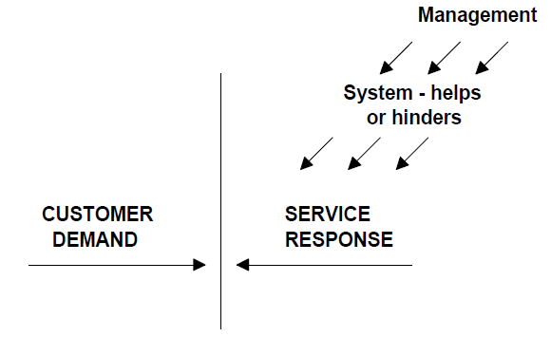

Source: VGuide, 2001a:38

#### Types of demand: value and failure demand

When examining the demand, each individual demand can following the response of the organisation be classified in one of the two groups – value and failure demand. The value demand represents those demands placed by the customer on service provision that are related to the purpose of the organisation. It is the demand, the satisfaction of which is the purpose of the existence of the organisation. The failure demand is every demand related to the inability to meet the demand typical of the value demand. For each organisation and particular service, the nature of value and failure demand is specific and thus it has to be defined based on the findings ensuing from the analysis of demand as such. The failure demand is generated mostly if the organisation failed to satisfy the customer at the first go or at the right time and fast enough. Or when it failed to do well the service preceding the provision of another service which is influenced by the quality of the former one. Thus, the organisations have to deal with demands that do not add value for achieving the purpose of their existence. Typically, these are repeated requirements asking for an explanation of what happens to the value demand, complaints about unsatisfactory service provision, etc. In public administration organisations the failure demand can account for up to 80 % of all customer demand and its removal can thus represent the greatest potential for increasing the organisation's capacities to satisfy the value demand (Seddon, 2009).

John Seddon (2009) states three underlying prerequisites for understanding the demand:

1. To understand **what the customers want from the organisation** in customer terms. To understand what points of transaction customers use for placing value demand. To understand when the demand is caused by a failure of the organisation to do something before, or a failure to do it right (failure demand).
2. The second step is to understand the **regularity and predictability of demand**. To know the typical day, week and month and demands received by the organisation, how many of them is related to the purpose and how many to the necessity to remedy the previous failures. Because only those received regularly by the organisation can be systematically removed, while irregular and therefore exceptional events are not caused by system design[2].
3. Finally, the third aspect of understanding the demand is revealing the **system conditions** that directly influence the nature of demand. By examining the everyday demand over a certain period of time findings are usually made that majority of failure demand is of similar nature and comes in the organisation regularly. It is caused by the design of the organisation. By changing the design and system conditions, the volume of failure demand to be dealt with by the organisation can be reduced. Identification of system conditions also represents one of the further steps of the VGM presented in the following chapters.

**Box 6: One possible way to analyse demand**

(Vanguard, 2001c:70-74)

1. **Selection of service for analysis and identification of points of transaction**

Organisations commonly provide a plethora of services. In order to obtain experience with application of the method, one particular service and processes leading to its provision shall be chosen.

After the service is chosen, all the points of transaction, through which clients demand the service, are identified. These are for example e-mail, telephone, information system, one-to-one meeting, etc.

1. **Collection of data at the points of transaction**

In this step it is necessary to most thoroughly analyse the demand coming to the selected points of transaction. Large organisations often collect certain data already in their information systems, which is however often fairly flat and lacks information from the customer's point of view. It is therefore usable rather as control data that is available continuously and indicates changes in the system's behaviour. To a lesser extent it indicates the causes of changes in behaviour of the organisation's system. In cycles, over a certain period of time, it is important to collect detailed information on demand at the points of transaction and on causes of the generation of failure demand.

The collection is done by:

1. managers spending some time at the front office and listening to the customers’ demands
2. front office employees recording every demand in a sheet where it is classified based on what the customer demands and what response he expects
3. **Type and frequency of demand**

The collected data can then be arranged into categories with similar demands of clients and frequency of demands in the monitored period for each category is calculated. Through this step we obtain information on how much and of what the customers expect to be provided by the organisation at the analysed point of transaction. Usually, apart from demand targeted at obtaining added value (e.g. “I would like to buy a new phone“), lots of demands caused by a failure in the first service provision is made (e.g. “there were no instructions for use attached to the phone”). The analysed categories can thus be divided into two types:

1. Value demand – clients demand the service which is embedded in the purpose of the organisation and in the purpose of the process, the aim of which is to provide the service. The organisation exists in order to satisfy this demand.
2. Failure demand – clients demand a response of the organisation rectifying the previous substandard service provision, or the failure to provide the expected service (“it does not work”, “I do not know where to look for the information”, “what happens to my demand”, etc.)
3. **Looking for causes of necessity to handle the received failure demand**

The last and cardinal step is looking for system causes of the already identified failure demand. The aim is to find the elements of system design which cause that customers regularly fail to receive the service they expect with respect to a certain type of demand. The change of system design based on the analysis of demand leads to releasing capacities for handling the value demand.

**Box 7: What have we learnt from the process of approval of project applications?**

The process of approval of project applications is the basic tool for getting projects the implementation of which should lead to accomplishing the objectives and the purpose of the operational programmes. The demand is constituted by project applications, the submission of which triggers the response of the body administering the operational programme in the form of a control process.

Apart from controls of project applications as such, the bodies administering the programme also carry out lots of activities preceding the control and directly influencing the nature of submitted project applications. It is especially the work with absorption capacity, its quality analysis, information on intentions, clarity of announced calls, etc.

Value demand in the process of approval of project applications is represented by projects that can be supported (eligible), because only approved projects have the potential to help accomplish the objectives of the operational programme. Failure demand is represented by all project applications which are not approved. It is because the work on their development and subsequent rejection is not offset by added value in the form of activities focused on improving the quality of life of people in the community. In this case, the failure demand constitutes a significant administrative burden and means a lot of wasted time on the part of applicants as well as on the part of the body administering the programme. The monitoring systems data from the 2007-2013 period shows a huge number of project applications that were not supported, which in some operational programmes represent more than 50 %. Thus, the analyses should aim at identifying the causes of generating lots of unsupportable projects and reducing their numbers. It would be conducive to releasing capacities for work associated with accomplishing the objectives of the operational programmes. A question arises to what extent the benefit of the operational programmes would change if the time spent on rejecting the project applications was spent on activities preceding the control process.



## Response capability

The third step of the VGM is a construction of measures. They serve as a tool for generating valuable data for improving the service provision. Apart from monitoring the satisfaction of customers, the VGM also includes a measurement of indicators reflecting those features of provided service that matter to the clients. The client is a person who determines by what measures the service quality is assessed. In case of a change in the system design, changes are manifested in the set measures of service quality and the organisation can thus monitor the impacts of changes (Vanguard, 2001b:106).

If the measuring of features of the provided service from the client's point of view is to be of value for the organisation's ability to learn and also to improve its own performance, the measures shall not become standards and the measures shall not be used for financial and other evaluation of employees. In case the target values are set, the indicators become a tool for monitoring the competency of individuals who at such a situation cease to pursue the interest of customers, and start to pursue their own interest which is the fulfilment of standards against which they are assessed (see Seddon, 2005).

Understanding of how regularly and predictably the system handles various types of demand, which of the demands it handles better, which worse and why, makes it possible to design the system optimally so that the response is stable and shows a long-term performance improvement. The aim of measures oriented at monitoring the response capability is to provide information not only to the organisation as a whole, but also to individual employees. They are then able to identify the causes of current performance and provide feedback to managers about how the system allows them to provide ideal services, or how it hinders them in this sense. The response capability is measured “from the outside in“, i.e. the capability of the organisation to respond to the demand is measured. It differs from “top down“ measurement which provides information on competencies of subordinates to meet the requirements of their superiors. Simply, the aim of the measure is to learn, not to demonstrate the competence.

### What to measure?

It is essential to measure the features which matter to service clients during the service provision. If it matters to customers that the service is provided at the moment they contact the organisation, the organisation should be able to find out whether the need was satisfied during the first contact between the client and the organisation. If it is duration of service provision which matters to the customers, then the organisation should measure how much time it needs to satisfy the demand from the client's point of view. Acting based on the set standards within 30 days (typical of public sphere) does not mean that within this period of time the service customers get the maximum added value from the use of this service. The deadline of 30 days is a typical “from the inside“ determined value acceptable for managers who decide about such deadlines. If the time of receipt of the output really matters to the customers, then a much better measure is to ascertain the timeliness of service provision from the actual service user. Thus the organisation is able to find out whether it achieves the purpose of its existence, or it leaves a lot to be desired.

Measures should be of two types, temporary (intensive) and permanent (cost-effective). The purpose of temporary measures should be in exploring the causes of performance, whereas the permanent measures monitor the performance relating to purpose as such.

The VGM builds on the assumption that prevailing majority (more than 90 %) of performance variability is influenced by the system. It means that despite different values will be seen in measured indicators in individual cases, their variability should always be almost the same (as long as the organisation's system is not in a state of disorder and does not change). In other words, measuring the capability to respond to customers' demands is fairly easy to predict in statistical terms since unless a major change is done in the system the performance in individual cases will range within no more than three standard deviations of the mean value. If the system design is changed, impacts of changes on the measured indicators can be observed.

In case of inappropriate design of the measure and its role within the organisation, multiple perverted effects might appear. These are associated especially with cases when based on measures also the employees are evaluated and when the target values are arbitrarily set. Where an employee is unable to satisfactorily fulfil the measured indicators for his superiors, often times the so called “gaming“ occurs, i.e. playing with numbers so that the employee is not considered incompetent. Or the risk of “creaming”, or selecting only those matters for addressing, which are the simplest and guarantee the best result of evaluation, and avoiding the challenging issues.

**Box 8: One possible way to measure organisations features which matters to its clients**

**Permanent measures**

Since it is a continuous measurement, it shall focus on quantifiable indicators, reporting on specific features identified in the previous steps. Altogether, the measurement should not constitute a major burden, and frequently the already collected data can be used. Permanent measures serve to monitor the system stability, and when changes are made they indicate the effects of changes on service quality. An example of this measure can be the following (Vanguard, 2001b:106):

1. **It matters to the customers that they receive full information during the telephone call so that they do not have to call again**.

*Share of telephone calls of customers when the customer did not have to call again and obtained everything he expected.*

1. **It matters to the customers that the service outputs are provided by the organisation within the agreed deadline.**

*Share of outputs provided in time.*

1. **The total time of service provision matters to the customers**

*Time from placing the demand to its completion thanks to the full service provision.*

**Temporary measures**

The aim of interim measurement is to intensively monitor the features of performance directly influencing the value of permanent measures, i.e. the quality of service, for a certain period of time. A part of intensive analytical activities should be directed at discovering such features and then to their thorough examination. This does not have to be only a quantitative measurement, but a more thorough qualitative examination of rules in the organisation, especially with respect to what structural causes of performance exist and in what way they impact the performance. Proper understanding of performance markedly increases the likelihood of success of changes introduced in the organisation.

Generally, both measures refer to those characteristics of performance which make difference to the final quality of the service from the point of view of client (both direct and final). Measures thus must be linked to the purpose of the organisation.

**Box 9: Response capability – how long does the beneficiary have to wait before he receives the decision on project approval?**

The monitoring systems used in the 2007-2013 period comprise data on duration of individual administrative processes. From the point of view of most types of beneficiaries, it is the total duration of provided service that matters, not the duration of its individual parts. It usually matters to the applicant/beneficiary how long it will take before he receives the final information on approval of his project. I.e. how long it takes after the submission of the application for payment before the money is received, etc. The performance of bodies administering the programme in terms of the time necessary for the issuance of the final decision can be easily monitored through the so called “control charts“. These are charts in which the individual cases representing individual demands with the total handling time from the applicant's/beneficiary's point of view are plotted. The individual cases can help derive the average duration and the deviations of the mean value which show how much the duration necessary for handling the individual demands differs. The system perspective assumes that the variability (or diversity) in the speed of handling the demands depends on the system design. It means that the variability and mean value reduction can be best achieved by a change in the system design.

**Process of approval of application for payment, Operational Programme Technical Assistance (OPTA)** 

Work on speeding up the administrative processes can begin by identifying the causes of occurrence of extreme cases, i.e. those that exceed three standard deviations of the mean value, or represent approx. 1 % of cases with extremely high or low duration. The “control charts“ are also suitable for monitoring the impact of changes of the system, when the actual impact of the change in the design on changes in behaviour, i.e. in the duration of the monitored process, can be observed. It is important to realize that variability is natural. Individual demands on service provision vary, their complexity and their wording vary too, etc. Setting out the target values of indicators largely results in ignoring this fact.

**The example above:**  Under the OPTA a paradoxical situation was identified. When all processes were plotted in the so called “control charts“, the most significant shift in handling speed was identified in applications for payment. Since the OPTA beneficiaries are government agencies, the control of applications for payment is not exactly the service in which the handling speed would matter to the customers since it is only an administrative act of a conversion of EUR into Czech crowns. Thus, it reveals the internal orientation of OPTA with the top-down perspective (what matters is to meet the obligations vis-à-vis the EC).

## Design of processes: value work and unnecessary work (waste)

What work is done in the organisation and how is the result of management decisions on process design. The managers decide on the distribution of roles, responsibilities, fulfilment of tasks, etc. The processes within the organisation can be broken down to two types, namely to “core” processes (client-oriented) and “support“ processes (oriented at client-oriented processes). Activities performed within these processes shall be evaluated based on the purpose of the processes, i.e. in “core” processes based on the ability to satisfy the needs of customers, in “support” process based on the ability to improve the quality of core processes (Vanguard, 2001a:93).

Activities within individual processes should be classified as “value work“ and “waste“. Value work is the work which adds value to the fulfilment of the purpose of the process, whereas unnecessary work is the work which gives no added value to the purpose. To identify the “waste“ or the unnecessary work means to discover the room for increasing the organisation's capacity. If the unnecessary work is limited, the capacity is released for the value work which can thus be performed better. There are three types of unnecessary work (waste):

1. If we stop doing this type of work, there would be no consequences (it is the easiest one to remove, there is however only a limited quantity of such work which means also only a limited potential for increasing capacities),
2. We can stop doing this work only by changing the rules and internal procedures (more difficult type of waste, but the organisation still has the capability and authority to change the conditions itself),
3. Work we can stop doing only provided the rules are changed, supported by external actors (the organisation itself does not avail of the authority and decision-making powers to change the rules and the design, the result of which this type of work).

In order to define the core and support processes, it is important to keep looking at the organisation's features from the outside. There is always a risk of approaching the analysis from the internal, functional perspective, which does make it possible to increase the effectiveness of processes indeed, but without reflecting their meaningfulness (meaninglessness). In order to minimize this risk, the following has to be kept in mind (Vanguard, 2001a:97):

* The starting point for looking at the design of processes is always the customer' point of view (i.e. the point of view of the person to whom the processes shall create the added value).
* Processes shall be analysed from the beginning to the end, i.e. from the moment when the customer first places the demand until the moment when his demand is fully satisfied.
* Process is measured in terms of the added value – how each part of the process helps create the output expected by the customer.
* Process is analysed by monitoring the flow of demand through the system. Each step, at which the demand is handled in a certain way, or shifted to the other parts of organisation, is analysed with respect to two aspects: to what degree it meant added value to the customer (quality of value work) and to what degree this activity was done efficiently (amount of waste).
* In process analysis it is useful to break down the processes into the core and support processes.
* Core processes are characterized by their direct orientation on work on the demand, i.e. on providing the service to the customer.
* Support processes are internal processes whose aim is to provide added value to core processes.

### Procedures during the analysis of process design

Metaphorically, the features of process design can be better examined when the demand is “pinned to the chest” and its each move is followed through the organisation until the final output satisfying the client. The design of process can be described simply as monitoring the handling of demand from its placing, step by step, until its fulfilment, during which process features are recorded. The features relate to the input in the process, processing of the input and handover of the output. These three aspects can be monitored at each step which the demand has to pass before it flows through the organisation back again to the customer in the form of an output (Figure 9).

***Figure 9: Flow of demand through the organisation up to the output for the client***

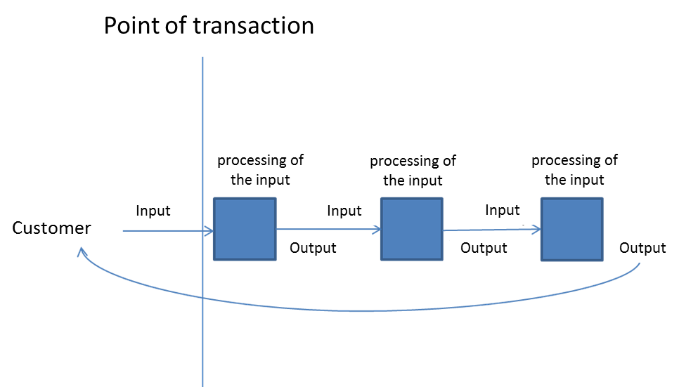

SOURCE: Author, inspired by Vanguard, 2001a

During the flow of demand through the organisation it is mapped and recorder to what degree each step adds value or does not add value to the output related to the client's demands, to what extent the flow of demand through the system is meaningful or to what extent it causes difficulties. For example the following questions are appropriate: “How often does this happen?“, “How many are affected?“, “How long does it spend in the analysed step?“, etc.

Subsequently, the so called “flow chart“ shall be built, or a diagram of the process design with individual steps through which the tasks from the external environment move. In each step the “measured” features can be recorded, for example how long the demand spends there, how many activities actually add value to the customer, how many activities are not related to the client's demands, etc. Then, the process can be presented to individual employees who are a part of the analysed processes, and a discussion may take place on whether the obtained data is valid, typical, etc. A visual presentation also increases the interest of employees in these matters and helps facilitate the thinking on features of the analysed process (Vanguard, 2001a:99).

What was said above can be simplified and reworded into several questions (Vanguard, 2001a:99):

* What is the purpose of the process? What is it trying to deliver to the customers?
* What is the value work? What matters to the customers?
* What is the flow? What are the steps the demand goes through before the customer's need is satisfied?
* Where and when the value is added to the client, i.e. where and when is the value work done which directly creates the added value for satisfying the customer's need? What else is being done and with what purpose?
* What helps or hinders the organisation in adding value to the outputs? What hinders the smooth flow?

**Box 10: Tips for analysis of process design**

1. **Collection of data with a view to providing a clear picture of performed activities within the particular process? (Vanguard, 2001c:92)**

***Questions concerning the inputs***: Is this the input because of processing of which we are here? Is the input ready for processing, or does it lack anything? How do the inputs in the process differ? How often do the individual types come in? What shall be done with them?

***Questions concerning the work with the inputs:*** What is done with the input? How many people work on the input before it becomes an output? How many times is it necessary to correct something? How often is it checked? How long and how often someone waits before he can do his part of the work? Does each individual performed action lead to pulling the input towards the output? Does everyone know what to do? What is the difference between the time spent on processing the output and the time from the receipt of the input to handover of the output to the client?

***Questions concerning the outputs:*** Where is the output moved? Does it satisfy the requirements of the user? How long did it take to provide it? Is it necessary to rework it?

1. **Identification of waste**

Once various information on what work is done and how is collected, discussions may start and individual actions can be divided into two types – value work which means added value for the client and waste which only hinders the performance of value work.

**Box 11: Tips for creation of a process map (Vanguard, 2001c:105)**

1. The previous activities should have resulted in a fairly large quantity of information about how the process of service provision is designed, i.e. how many individual steps are there, where is the waste, how many and what inputs are involved in every part of the processes, what outputs are produced by the process, etc.
2. From the point of transaction to the service provision, make a list of individual steps of the process leading to the output for the client.
3. To such a map add various values you were able to measure. For example the type and quantity of inputs in the process or its parts.
4. For each step of the process write down the identified waste and classify it into individual types. Describe the nature of the thus created categories and try to identify how often they are performed and under what conditions.
5. For each point of the process write down the impact of the activity/waste on the resulting service provided to the client, or on the client's satisfaction with the organisation's output.

**An example of a process map (process of notification of a change under the OPTA)**



**Box 12: Work No 1, work No 2 and monitoring**

Value work can be of two types. Work No 1 means a standard operation, handling the demand from its receipt to the provision of the output to the client, whether it is a client from the external environment with respect to core processes, or from the environment of the organisation itself with respect to support processes. Work No 2 is related to activities aimed at improving the quality of work No 1. This work No 2 is very important since only a quality work No 2 guarantees that the organisation keeps pace with the dynamic external environment.

An example of work No 2 in the ESIF environment is monitoring. Collection of data on how the implementation of operational programmes is doing, represents the value work No 2. It is the case, however, only when the monitoring helps improve the quality of implementation processes. If monitoring has in fact no impact on regular operation, it can be considered the waste.

**Examples of waste (Vanguard, 2001c:93)**

* Necessity to do certain work again because it has not been done right for the first time
* Duplication of efforts (the same document has to be studied by more persons)
* Doing things which have absolutely no added value to the customer
  + Completing forms and papers the usefulness of which is hardly known to anybody
  + Waiting for the appropriate supporting documents/equipment
  + Work based on inadequate/unreliable information
  + Necessity to remedy problems caused by a failure to perform the tasks thoroughly earlier in the process
  + Fire-fighting – resolving the consequences of the problem rather than its causes
  + Attending useless or badly chaired meetings

**Box 13: Waste in the Operational Programme Technical Assistance (OPTA)**

Under the Operational Programme Technical Assistance, it was the process of announcement of a change in submitted project that was paid major analytical attention. Managing authority need to process the change announcement so that project can run differently from the original submitted one. The analysis revealed a single system element which caused a fairly large amount of waste. When the factual causes of the submission of announcement of a change were closely looked into, of 340 monitored cases 48 were caused by a change of the statutory representative of the operational programme. Since the beneficiaries under the OPTA are government agencies, namely the Ministry of Regional Development and the Ministry of Finance, the process of handling the announcement of a change was in 48 cases triggered by a change of the minister. This was, however, a piece of information generally known from newspapers. Allowing for a change in the statutory representative of the project in government agencies without the necessity to launch the whole process of notification of a change would thus bring about a reduction in the number of handled notifications by 14 %.

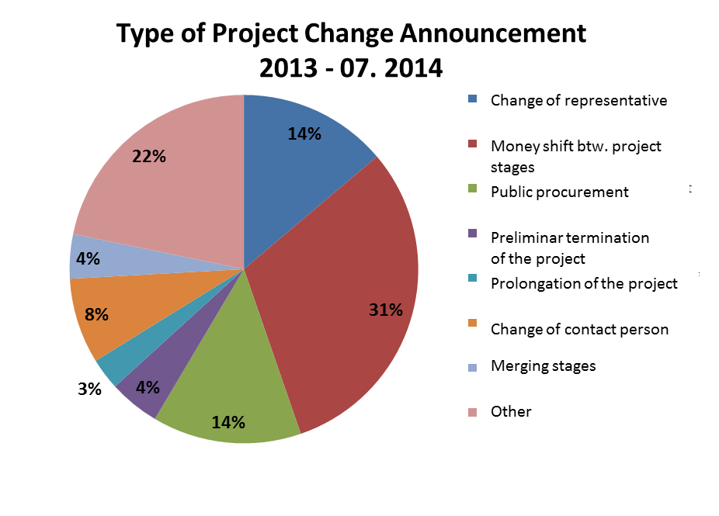

## System conditions

How much of value and failure demand the organisation receives, how capable it is of responding to it, how much unnecessary work (waste) it does in the process, etc. is to a large extent determined by the so called system conditions. These are particular elements in the organisation system, which are able to influence the actions, and thus also the way in which the work is done in the organisation. It is for example the design of organisational units and relationships between them, roles with the assigned responsibilities, tasks, superior-subordinate relationships. And also the presence of values generally recognized in the organisations, the observance of which is requested from its members similarly as the adherence to the formalized rules. Equally important are also the habits which are manifested for example in the way of fulfilling similar or repetitive tasks. The habits are often depersonalized, which means that they do not depend directly on the particular person, but are linked to the roles, present in the organisation over a long period of time. The members of the organisation initiate also the newcomers in those habits, by which the habits tend to sustain.

Let us now engage in more details in the following elements: work design and structure, measures, roles, information and policies (VGM, 2001a:111).

**Process design and structure** means how meaningfully the organisation is divided and into what working units, how relationships between them are designed, etc. Public institutions have traditionally been viewed as a hierarchy and are thus seen in the top-down perspective. The VGM turns this perspective over to the ”outside-in“ perspective. The analysis of organisation from this perspective divides the processes into core and support processes and monitors the added value of the work done in these processes against the organisation's purpose. It reveals also the internal horizontal aspects of public organisations since it relates all the activities to a single purpose, and defines roles leading to its achievement. It is then possible to observe to what extent each organisation unit contributes to the common purpose and to what extent it performs activities which on the contrary hinder its achievement.

**Measures** are of similar nature. They show what matters to the organisation. What the organisation considers as value because of which it is necessary to gather lots of information. In case of their poor design, they can become a serious threat to the actual performance of the organisation. Especially two aspects of the design of measures tend to have significant unintended effects.

Firstly, it is taking the measures into account in the evaluation of employees. In other words, it is an effort of managers to motivate employees by introducing measures to their work in order to check their performance. Several problems arise in this context. The employee starts to take care about fulfilling the measured indicators also if attention shall be paid to other aspects. In case he is unable to appropriately fulfil the measured indicators for his superiors, the so called “gaming“, or “creaming“ occurs (see above). Conversely, those who have no problem to achieve the target values set by the manager, can slow down. Simply, the target values of measured performance are set arbitrarily, with no account taken of abilities of individual employees.

The second issue is represented by managerial monitoring of the measured values for individual working units, sections, etc. and monitoring of performance of these smaller units, regardless of how they contribute to the overall functioning of the organisation. The measures are not set for the system as a whole, but for its individual parts only. Hence, the individual units seek to achieve the best possible results in the monitored indicators and shift the problems that could make their results worse, further in the system. This increases the amount of necessary waste and reduces the overall performance.

**Roles** are associated with expectations to be fulfilled by employees in a certain position. In line with the design, more specialised roles are present in the system and thus the work is more fragmented, or on the very contrary the organisation prefers such positions in which the employees cover a broad agenda. The VGM advises to reconsider the roles in the organisation along two aspects. First of all, it underlines the need of the organisation to join two works in each role – work on a regular agenda (work No 1) and work on developing the work being done on a regular agenda (work No 2). The latter aspect is directed at the responsibility of the organisation's members. In case of managers, it is the responsibility to set the system conditions which will make it possible that also work No 2 is done. Then those, who directly perform the activities, are best able to identify the shortcomings of these activities, but have to be a part of the organisation which encourages identification of shortcomings. The managers should be able to collect information on causes of shortcomings in the system design from employees who actually handle the demand, and based on the findings to take actions with respect to the design of the system.

**Information and their transfer in the organisation** represents a very important feature influencing in what way the work is done and especially based on which the decisions are made. The point is whether everyone always at the right point of time has at hand the largest amount of information that he currently needs. A very useful tool with an extraordinary potential to ensure availability of information is IT technologies. Quite often, however, the complex IT structures apart from useful information provide also loads of unnecessary information. Or, they are used for collection of huge amounts of data that are subsequently not exploited. IT technologies should always be perceived from the perspective of the added value against the work done by their users. Not all the tools that can be implemented in the IT technologies and that are offered by the companies add value through. Just as in other tools, it also depends on the particular organisation and the demand it handles.

**Policies** also tend to be extremely important for the nature of the work done since they embed certain rules governing the work performance. Moreover, they are often difficult to change, which is why their introduction should always be carefully considered. Just like the other aspects, the content of the policy and its effects should be compared against the degree to which they will enhance the organisation's capability to achieve its purpose and to which they will hinder it. For example, the policy representing the connection between the evaluation of employees and their performance in certain criteria will bring what was mentioned above in discussing the measures, the so called “gaming“ and “creaming“.

Apart from what was said above, also a number of other system conditions can be identified, which have a substantial impact on operations within the organisation. When system causes are sought, it is appropriate to constantly ask the question: “Why does the monitored work look exactly like this?“ or “Because of what this or that is done in this very manner?“. Where the system conditions are not identified, the efforts to increase the performance can bring only very limited outcomes. Change of work while maintaining the system conditions has the potential of certain limited optimization, but is unable to influence the actual meaningfulness of performed activities. Typical is experiencing of such problems as a lack of resources, too many priorities, growing costs, increasing expectations from those around, too strict rules, ever growing pressure on employees, etc. This is followed by typical solutions such as the necessity to increase the number of employees, setting of more precise target values of indicators, working overtime, work prioritization, etc. The VGM reckons with a different approach which is characterized by identification of waste and failure demand, system conditions from which the findings are derived, and finally the assumptions based on which a perfect performance of the work was originally expected.

**Box 14: System conditions under the OPTA – management of the operational programme**

One of the system conditions of the OPTA 2007-2013 was the design of the implementation structure which included three units – Department of the Managing Authority (MoRD), Budget Department (MoRD), Intermediate Body (CRD). Moreover, this structure complex for such a small programme moreover lacked strong hierarchical arrangement, thus a number of fairly minor issues had to be on a roughly weekly basis discussed with the implementation structure managers on the so called tripartite meetings (this was most likely a source of unnecessary work (waste) in the form of high transaction costs of generating decisions, low flexibility of decision-making, etc.).

This system design was probably the result of an idea of top managers responsible for the design of the OPTA implementation structure not written in any document that it is risky to concentrate the responsibility into a single unit. Because of that the OPTA structure was created based on the balance of power.

## Identification of management thinking: assumptions shaping the performance of organisation

The step number six is crucial. It should result in revealing the assumptions based on which the system of the organisation is built. These are assumptions of managers that are often not explicitly articulated. The assumptions of managers why they consider their decisions concerning a particular design of the system correct and why they believe they will work and improve the operation of the organisation. The held assumptions drive the decision-making of managers without them realizing it. Since they are undeclared and no thorough analysis is carried out, the unintended consequences ensuing from the assumptions are often not revealed. Thus, the system is trapped in single-loop learning and is unable to achieve a change in the quality of performance since the unintended consequences of rigid management assumptions are still present.

The identified system conditions always build on certain assumptions concerning their functionality. For example, the design of measures shows what is emphasised in the organisation (Figure 10). The design of the system of measures is based on the assumptions of managers about features which are crucial for performance of the organisation, or features that contribute to achievement of its purpose. Thus the organisation will achieve the purpose which is measured. As H. Thomas Johnson put it: “What you measure is what you get.“ This kind of process of changing consequences by not only changing behaviour but also by changing assumptions behind the behaviour is in organisational theory known as double-loop learning (see Argyris, Shön, 1978).

*Figure 10: Double-loop learning, change of performance as a result of change of thinking*

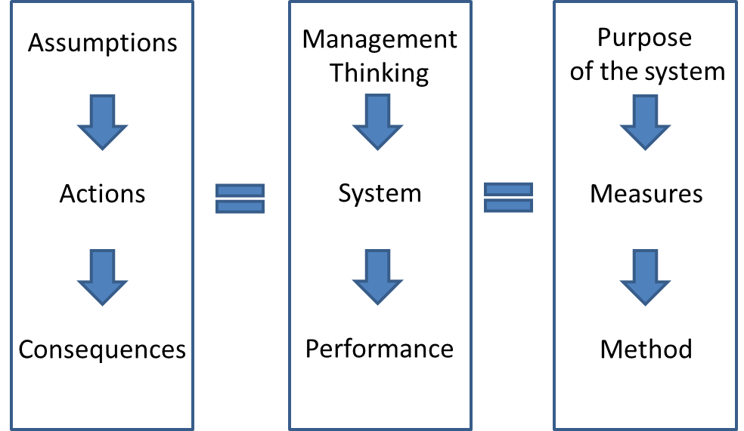

The VGM is largely presented based on its comparison against the traditional way of management originating in the industrial period of the Euro-Atlantic civilization. In the Czech setting the “command and control“ management system, typical for corporate and industrial management, has not been developed to a degree as for example in the United Kingdom, to which the VGM responds in particular. Despite of that the Czech managers have certain assumptions associated with the traditional management. This is why at the end of the chapter presenting the “check” phase of the Vanguard method a short comparison of assumptions of the traditional management and the systems thinking is provided (the text is based on Vanguard, 2001a:124-142). Even though each organisation is built on more or less different assumptions, it is most likely that some of the below reflected assumptions of the “command and control“ management are present also in your organisation.

***Table 2: Selected principles present in the managers' thinking, differences between the “command and control“ and “systems thinking“***

|  |  |  |
| --- | --- | --- |
| “Command and control“  principles |  | “Systems thinking“  principles |
| Top-down, hierarchy | **Perspective** | Outside-in, system |
| Functional specialization | **Design** | Demand, value, flow |
| Separated from work | **Decision-making** | Integrated with work |
| Outputs, standard objectives related to budget | **Measures** | Capability and variation, related to purpose |
| Extrinsic | **Motivation** | Intrinsic |
| Manage plans, budget and other monitored criteria and manage employees | **Management ethic** | Act on the system |
| Contractual | **Attitude to customers** | What matters |

Source: Vanguard, 2001a:125

**The top-down perspective of** viewing the organisation is characterized by nominal value of quality being set from the top by managers. Individual parts of the organisation work the way the managers consider appropriate. Organisations with such management perspective are rather closed, unable to flexibly respond to external environment since the decision-makers get into the contact with it only indirectly. The **outside-in perspective,** on the other hand assumes, that it is the customer who determines what the outputs created by the organisation shall look like. The main principle is to develop the understanding of how the customers pull value from the organisation and how the organisation can increase its capability to meet the clients' demands. Simply, there is a difference in assumptions as to who knows the best what the organisation shall produce – whether the managers or the clients.

**Work design** in organisations with traditional hierarchical management is **functionally structured**. In other words, the organisation is divided into working units based on specialization into partial tasks. At the same time, in the organisation managed in this way performance criteria for individual functionally separated working units are defined. Then, the performance of these units is monitored and optimized so that the managers can check the organisation's performance. A problem arises with respect to a certain separation of individual units from the production of the organisation as a whole. Usually, it becomes a key challenge to managers of the functional units to achieve the performance measures at any cost. Therefore, also at the cost of shifting problematic cases further in the system so that the performance indicators report a positive value even though the necessary work was not done with respect to the task. **System perspective** focuses on demand and on how it is pulled through the system up to the moment when the client's demand is satisfied. It focuses on the highest possible performance of the process “end to end“. Essential is not the pressure for increasing the performance of functional units, but for the system design which makes it possible to handle the demand as fast as possible and in the highest quality. The traditional perception follows from the assumption that the division of tasks into multiple simpler actions and subsequent work towards faster execution of smaller actions leads to an increased performance. The system perspective, on the contrary, assumes that the system as a whole creates a higher value than the mere sum total of its individual parts, and thus divides the task into actions only where it ensures better flow of the demand through the system “end to end“.

**Decision making** in a **traditionally managed organisation** is viewed as a task of managers and thus is separated from work actually done on the outputs for clients. The managers decide in what manner the work will be done and the employees act accordingly. The **system management** puts more stress on integration of decision-making with the work. It enables the employees performing often complex tasks to decide on a case-by-case basis in order to adapt their behaviour to the demand as best as they can. This increases the capability to respond to variable demands ensuing from the external environment. The assumptions of individual management thinking differ regarding the extent to which the employees are considered inapt and untrustworthy and the extent to which, on the contrary, their activities as creators of added value for the clients are considered important. Reinforcing the integration of decision-making with the work has also positive effects on satisfaction of employees with their jobs since they have more room for self-fulfilment and influencing the quality of outputs.

**Measures** in **the traditional management** are related to checking the employees and the extent to which they adhere to the procedures and outputs defined in a standard manner. The measures focus primarily on checking the budgets and the way of spending the funds. The productivity as well as the degree of achievement of the planned values, both financial and performance-related are monitored. The traditional measures are troublesome since they do not reveal why the organisation does as it does. Conversely, the organisation with a **system management** uses the measures especially for enhancing the capability to learn about its own performance. The organisation obtains information on the bottlenecks and on things which need more attention. Causes of high costs are monitored, but not only the high costs as such. Monitored is also the organisation's capability to meet its purpose and the features of the performance which often directly influence this capability. Information is constantly obtained from the customers in order for the organisation to be able to continuously adapt to their demands and to the external environment. It is assumed that it is more important to measure what helps the employees get better in achieving the purpose than to measure just for the sake of checking the performance and pressing for its increase.

**Traditional management** relies on external **motivation** of employees. Specialization and measuring performance of individual units as against the standard values defined by the management lead to a growing pressure on the capability to achieve the measured values. Such organisations often motivate their employees by certain bonuses obtained in case the set values are achieved, or sanctions where indicators are not fulfilled, etc. The problem is that the employee is not in control of the situation, but only obeys, and the motivation comes from the outside, from incentives and threats. The **system perspective** tries to present the tools for enhancing internal motivation of employees. Integration of decision-making with the work strengthens autonomy, the measures serve for learning and the system in general helps achieve self-fulfilment and mastery in what the employees do (see e.g. Pink, 2011). It is assumed that internal motivation is stronger than the external one and for this reason the employees increase their performance in a more natural way.

**Attitude to customers** is then **traditionally** perceived as contractual. It assumes that the clients want a certain amount of the same service. The managers assume that they are able to define such service and subsequently monitor the implementation of their own ideas. The **VGM** highlights particularly what matters to the clients and assumes that their needs and desires differ substantially. Such thinking leads to the provision of services of better quality since the service is more flexible and thus results in more satisfied clients.

**The management ethic** consists in **traditional style of** people **management**, in increasing their performance, accomplishing the plans concerning the budget set from the top, etc. The roles of managers in the **system perspective** lie especially in the ability to collect information on actual performance and in subsequent acting upon them vis-à-vis the system, or in modifying the system conditions in order to increase the performance. Systems thinking assumes that the organisation's performance is mostly driven by system conditions, not by people.

**Box 15: Preparation of projects under the ESIF Czech Republic**

The specific, usually unexplained management thinking can often be seen in the undeclared assumption that the highest quality of projects can be achieved best by allowing for free competition among the applicants. It is usually done by announcing time limited calls for submission of projects, in which the applications commonly exceed the available allocation of the call. Then, the announcer through an expert evaluation supports those projects that are perceived as the best by the evaluators.

Surprising in this respect can be the fact that the canonical version of methodology “project cycle management“ (see e.g. EC, 2004) includes a different “management thinking”. The PCM works on the FIFO principle – the announcer of the call continuously receives pre-feasibility study the quality of which he seeks to maximize through the cooperation and mutual interaction of experts of the applicant and the provider. This approach minimizes the volume of work spent on project applications which are in the end not supported and which represent failure demand.

The hypothesis that free competition without a considerable support of the announcer leads to a higher quality of selected projects has not been confirmed and it is not certain either that the evaluators are truly able to select the best projects. Frequent are their complaints such as “I have no reason to deduct points from the score of this project, formally the project is right, but it lacks the right spirit“.

**Box 16: Uncovering management assumptions: measuring standards**

The system illustrated below aims at meeting the pre-defined standards that can be directed at efficiency, quality of services, etc. If a more detailed analysis of the service shows that it is of poor quality and the set out standards do not meet their purpose, the design of standards shall be changed. Over and over again. “If you are doing the wrong thing, then doing it better makes you wronger, not righter.” (Caulkin) The fundamental issue is that in the system designed in this manner there is no criticism of thinking that is behind its construction. Thus it is only the so called “single loop learning“ characterized by its inability to substantially improve the quality of the system functioning.

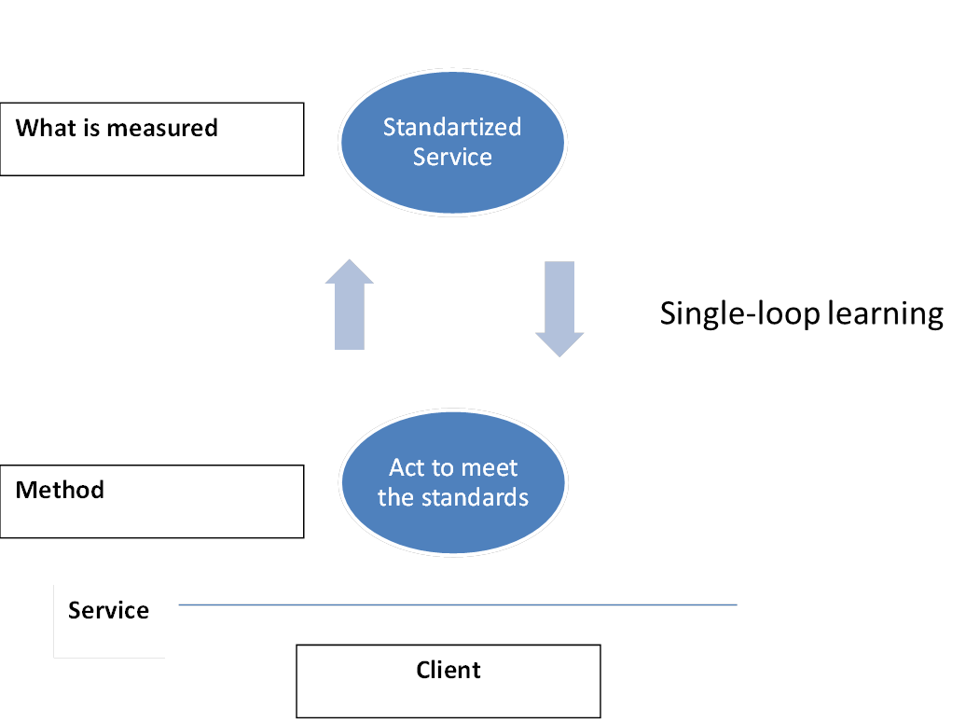

Closely related to the above presented features of standards is the statement “you are what you measure“ (see e.g. Hauser, Katz, 1998). In order to be able to think about how to do the right thing and not how to do the bad thing better, it is necessary to reveal the level of thinking from which the measures to monitor the system performance are derived.

**Box 16: Uncovering management assumptions: measuring standards (continuation)**

The system oriented at achieving quality through standardization meets simply the purpose of “providing same quality service to every client”. Nonetheless, the standard service does not have to be identical with the service satisfying the clients' needs. The need is not the same as the standard; it is of a far more comprehensive, variable, broader and qualitative nature, whereas the standard is of a quantitative and necessarily simplifying nature. It will be extremely difficult for the system of such design to identify when it meets the substance of the service as such since it will be busy with identifying whether the services are provided in a standard manner.



In case of change of the purpose of the system to “provision of services perfectly reflecting the requirements of our clients” the measurements structures would probably acquire a different nature.

## The process of constant learning

The analytical phase should bring answers to following key questions:

* How does organisation work as a system?
* What are the key assumptions on which the organisation’s system is created?
* What is the potential for improvement?
* On what should be the redesign of the organisation focused?

It is convenient to plan an experiment to find out answers to those questions. Because *Vanguard Method* usually leads managers and workers to thinking about radical change in the process setting it is suitable to test such setting without any hesitation on a small part of the organisation. Such test will bring findings about what works and what does not work. It is then appropriate to transfer useful and verified things in common functioning of the organisation. And then you have to start again from the beginning with either quicker or more thorough analysis. This is the only way how the organisation can keep pace with the changing environment.

The purpose and assumptions can never be perfect. The external environment keeps changing and also changing is the experience and perception of the external environment by the organisation's employees. The VGM cycle offers an approach thanks to which the purpose of the organisation can be made more accurate and ever better assumptions for management decisions on the design of system conditions can be found. Equally the organisation continuously improves its ability to generate quality basis for management decisions. *Vanguard Method* offers a way to foster continuous learning process which ensures that the organisation remains valid to its purpose of existence.

# Sources

Anderson, L. 1994. *Argyris and Shön’s theory on Congruence and Learning.* [online] Available on [http://infed.org/mobi/chris-argyris-theories-of-action-double-loop-learning-and-organisational-learning/](http://infed.org/mobi/chris-argyris-theories-of-action-double-loop-learning-and-organizational-learning/). Downloaded on 8 Apr 2015

Argyris, C. Shön, D. 1978. *Organisation learning: A theory of action perspective.* Reading, Mass: Addison Wesley

Bourgon, J. 2011. *A New Synthesis of Public Administration: Serving in the 21th century*. McGill-Queen’s University Press

Caulkin, S., *Kittens are evil: heresies in public policy,* available online on <http://www.simoncaulkin.com/article/406/>

EC. 2004. *Project Cycle Management Guidelines.* Brussels: European Commission

Hauser, J., Katz, G., 1998, *Metrics: You are what you measure,* Cambridge: Massachusetts Institute of Technology, available online on <http://web.mit.edu/hauser/www/Papers/Hauser-Katz%20Measure%2004-98.pdf>

IROP. 2014. *Poslání IROP, Strategie realizace Integrovaného regionálního operačního programu na léta 2014 až 2020, pracovní verze 2014*

Jackson, M. 2003. *Systems Thinking: Creative Holism for Managers.* Chichester: Wiley & Sons

MPSV. 2011. *Mapa strategie odboru řízení pomoci z ESF, pracovní verze 2011*

Pink, D. 2011. *Pohon – Překvapivá pravda o tom, co nás motivuje!.* Praha: Anag

Seddon, J. 2005. *Freedom from Command & Control: a Better Way to Make the Work Work*. Buckingham: Vanguard Consulting Ltd.

Seddon, J., 2007, *Public Sector Targets: Doing Less of the Wrong thing is not Doing the Right Thing,* Buckingham: Vanguard Consulting, Ltd., available on <http://www.systemsthinking.co.uk/9-publicsector.asp>

Seddon, J. 2009. *NI 14 (’Avoidable Contact‘): From the Horse’s Mouth,* [online] available on <http://www.systemsthinking.co.uk/ni14horse.pdf>, downloaded on 26 Mar 2015

Seddon, J. Caulkin, S. 2007. *Systems Thinking, Lean Production and Action Learning,* Action Learning: Research and Practice, Vol 4., No. 1., [online] available on <http://www.tandfonline.com/doi/pdf/10.1080/14767330701231438>, downloaded on 26 Mar 2015

Seddon, J. Donnovan, O. 2009. *Rethinking Lean Service.* [online] available on <http://www.sixsigmaiq.com/downloadSecureContent.cfm?ID=10>, downloaded on 8 Apr 2015

Seddon, J. Donnovan, O. 2010, *Why Aren’t We All Working for Learning Oganisations?.* E-Organisations & People.Vol. 17. No. 2. [online] available on <http://www.systemsthinking.co.uk/docs/0500whynotallworkingforlos.pdf>

Smith, M. 2013. *Chris Argyris: theories of action, double-loop learning and organisational learning,*[online] available on [http://infed.org/mobi/chris-argyris-theories-of-action-double-loop-learning-and-organisational-learning/](http://infed.org/mobi/chris-argyris-theories-of-action-double-loop-learning-and-organizational-learning/), downloaded on 8 Apr 2015

Statista. 2014. *Global number of Volkswagen AG employees from FY 2008 to FY 2014,* [online] available on <http://www.statista.com/statistics/272052/worldwide-number-of-volkswagen-group-employees/>, downloaded on 8 Apr 2015

Toyota. 2014. *Toyota Overview,* [online] available on <http://www.toyota-global.com/company/profile/overview/>, downloaded on 8 Apr 2015

Vanguard, 2001a, *Understanding Your Organisation as a System,* Buckingham: Vanguard Consulting Ltd., [online] available on [http://blog.newsystemsthinking.com/wp-content/uploads/TheVanguardGuidetoUnderstandingYourOrganisationasaSystem.pdf](http://blog.newsystemsthinking.com/wp-content/uploads/TheVanguardGuidetoUnderstandingYourOrganizationasaSystem.pdf), downloaded on 26 Mar 2015

Vanguard, 2001b, *Using Measures for Performance Improvement,* Buckingham: Vanguard Consulting Ltd.

Vanguard, 2001c, *Process Mapping and Analysis,* Buckingham: Vanguard Consulting Ltd.

Wauters, B. 2012. *Sourcebook on Results Based Management In the European Structural Funds,* COP RBM, [online] available on <http://www.coprbm.eu/index.php?q=node/630>, downloaded on 8 Apr 2015

Zokaei, K. Simon, E. et al. 2010. *Lean and Systems Thinking in the Public Sector in Wales.* [online] available on <http://www.wao.gov.uk/system/files/publications/Lean_and_Systems_Thinking_in_the_public_sector_English_2010.pdf>. Downloaded on 8 Apr 2015

# List of figures, tables and boxes

**Figures**

Figure 1: Conventional concept of Technical assistance (p. 10)

Figure 2: Technical assistance adding value (p. 10)

Figure 3: Basic chart of the Vanguard method (p. 19)

Figure 4: Vanguard method cycle (p. 19)

Figure 5: Capacity of the organisation viewed by the Vanguard (p. 21)

Figure 6: Chart of the Check! Phase of the Vanguard method (p. 22)

Figure 7: “Outside-in” perspective of the organisation (p. 23)

Figure 8: Chart of the relationships between the clients of the service organisation and the response capability of the organisation (p. 30)

Figure 9: Flow of demand through the organisation up to the output for the client (p. 39)

Figure 10: Two-loop learning, change of performance as a result of change of thinking (p. 48)

**Tables**

Table 1: Different principles of the traditional “command and control“ management thinking and “systems thinking“ (p. 17)

Table 2: Selected principles present in the managers' thinking, differences between the command and control and systems thinking (p. 49)

**Boxes**

Box 1: Who is the client under the ESIF? (p. 22)

Box 2: How to proceed in defining the purpose of the organisation/the purpose of the process? (p. 25)

Box 3: Example of defining the purpose in organisations active in the ESIF (p. 26)

Box 4: One of the procedures how to generate data relevant for client-driven perspective (p. 28)

Box 5: Meeting with the OP HRE beneficiaries (“focus group“) (p. 29)

Box 6: How to proceed in demand analysis? (p. 32)

Box 7: Value and failure demand under the operational programmes in the Czech Republic, process of approval of project applications based on the monitoring system data (p. 33)

Box 8: How to measure the response capability of the organisation from the clients' point of view? (p. 36)

Box 9: Response capability – how long does the beneficiary have to wait before he receives the decision on project approval? (p. 37)

Box 10: Tips for analysis of process design (p. 41)

Box 11: Creation of a process map (p. 42)

Box 12: Work No 1, work No 2 and monitoring (p. 43)

Box 13: Waste in the Operational Programme Technical Assistance (p. 44)

Box 14: System conditions under the OPTA – management of the operational programme (p. 47)

Box 15: Preparation of projects under the ESIF Czech Republic (p. 52)

Box 16: Standardization as a tool of provision of quality service? Brief discussion on single-loop and double-loop learning (p. 53)

1. It is little-known that ISO 9001 standard was based on the older British standard BS 5750 that was created in order to observe the *safety* standards in war industry (e.g. in munitions factories). Thus, ISO 9001 contributes rather to safety implementation of processes than to their effectiveness.
2. The Vanguard Method is an approach suitable for organisations that exist in order to satisfy at least a partially regular or predictable demand. Where the organisation operates in the area where it is impossible to predict what the clients will want, need, in what amount and when, other approaches shall be opted for.